**Starting a Fluorostat Run**

**Equipment**

Autoclave all the glassware

Batch Mode



* Vial with stir bar and temperature probe. (foam cap for stirring or metal cap for aeration)
* Make sure the fluorescence probe is in ethanol

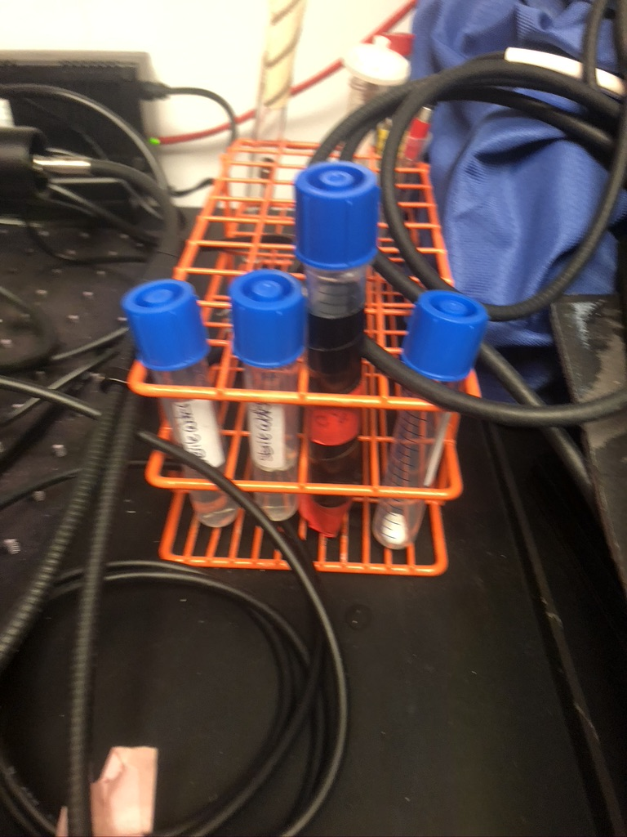

Turbidostat Mode

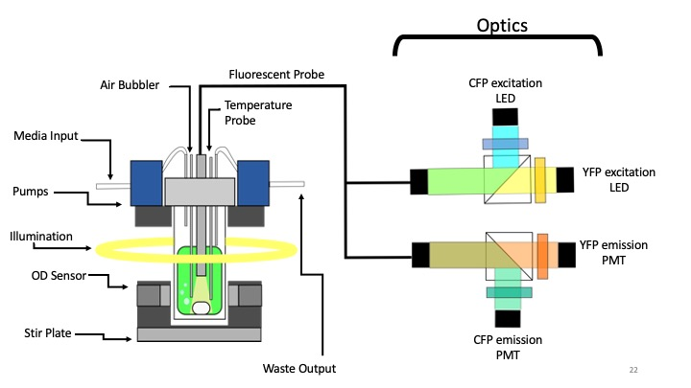

* Vial, media, and waste bottle connected by tubing
* Prepare media in the media bottle before autoclaving
  + Tie off media tube so media doesn’t go into sample vial
* Make sure the fluorescence probe is in ethanol

**Strain Preparation**

Before your run you will want a 30 mL flask of your strain growing in exponential phase.

* I will typically start a flask from either a test tube or bench stock, 2/3 days before the planned experiment.
* The day before the experiment (at a fixed time, typically between 3-5 for me) dilute 1/30 into a new flask. For most strains this will put the OD at around .4 the next day.
* The day of the experiment, measure the OD of your sample. Dilute to approximately OD750 .1.
* Put 20mL of culture into the sample vial.

**Prepping Fluorostat**

To turn on the fluorostat:

|  |  |
| --- | --- |
| 1. Plug in power strip and Plug in fish pump (if aerating)    | 1. Turn on motherboard    |
| 1. Turn on Light Module    | 1. Before you start the run you will need to turn on the LED driver (turn clockwise as far as it will go)    |

* Log in to computer [Password: Fluorostat]

**Software**

You need two programs to run a fluorostat run: Arduino and python

Arduino

* Go to the command line and cd into the Arduino folder

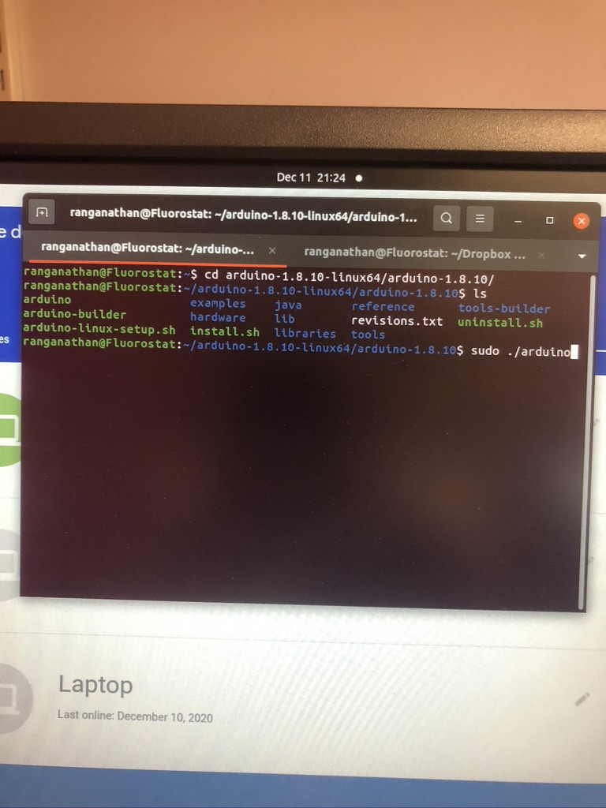

* Open Arduino (you need to run as sudo otherwise you’ll run into problems):

-----CODE--------------

cd arduino-1.8.10-linux64/arduino-1.8.10/

sudo ./arduino

* Open “TwoColors_Air_LD_chem.ino” located in Dropbox (Rust Lab)/Chicago/Code

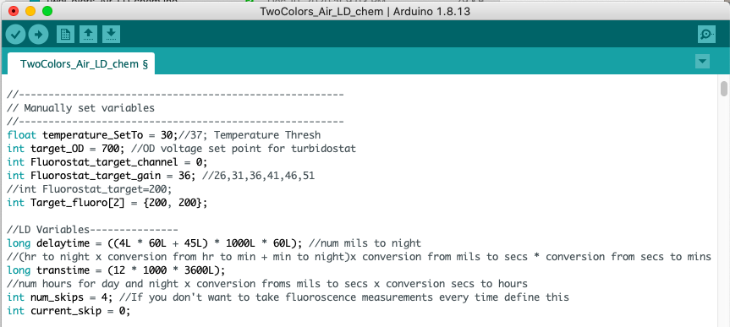

Python

* The python script is located in the dropbox folder: “Dropbox (Rust Lab)/Chicago/Code”
* The command should be run after the Arduino code is started (need to specifically call python3) “Twocolors_modified_linux.py”

**Start a Run**

|  |  |
| --- | --- |
| 1. Rinse the probe with sterile DI water | 1. Place the probe in the vial    |
| 1. Plug in the thermocouple    | 1. Turn on illumination and LED driver if you haven’t yet    |
| 1. Place the vial in the holder    | 1. Cover the sample holder with the black box    |

* On Arduino at the top of the script manually set variables as needed (such as temperature, OD set point, and Day night transition)



* uncomment the run mode you want and upload in the loop function at the bottom

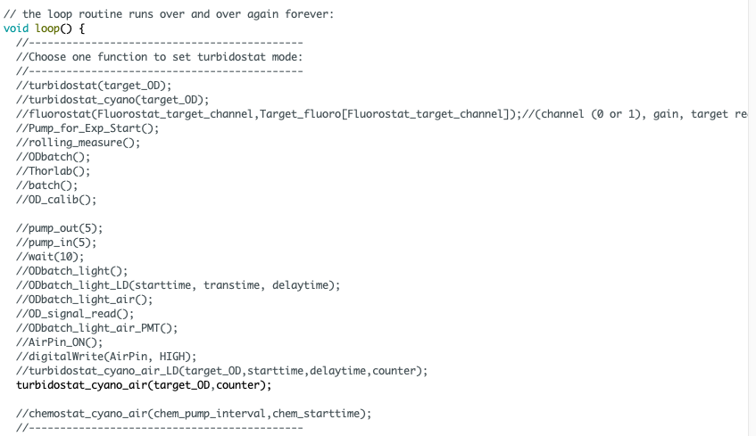

* Click the upload button in the top left, once it has been successfully uploaded, the console at the bottom of the Arduino window will say “Done Uploading”. The fluorostat will begin running, although no data will be collected until the python script is run.



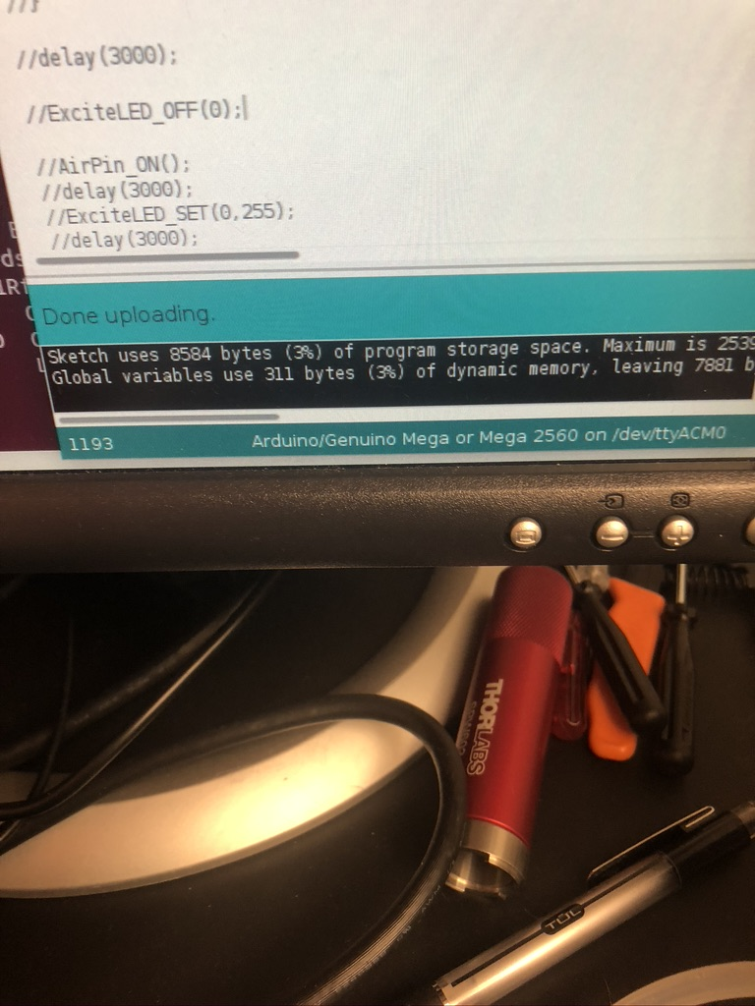

* Once uploaded, run the python code “Twocolors_modified_linux.py”

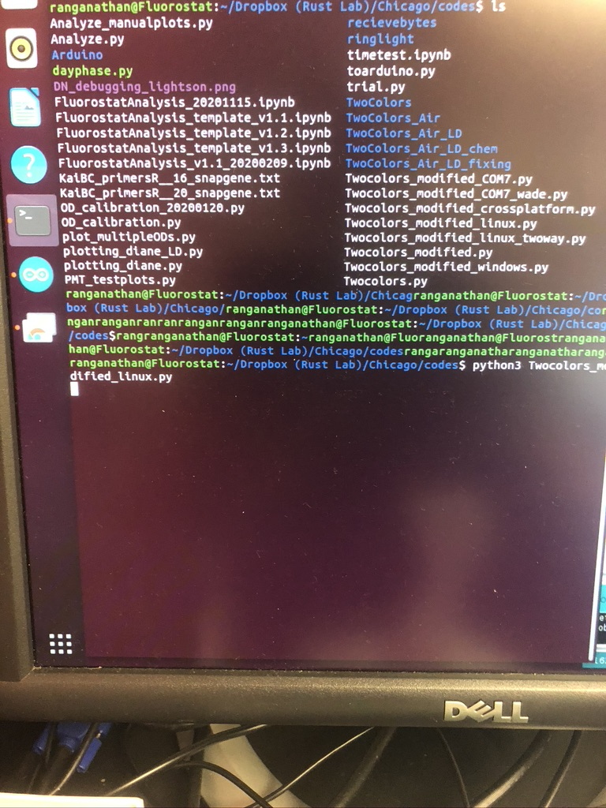

-----CODE--------------

cd Dropbox (Rust Lab)/Chicago/Code

python3 Twocolor_modified_linux.py

Upon running the code, the terminal will begin printing the collected data, which will be stored in a csv. An interactive matplotlib window will open and show the status of the current run.

Sometimes this will throw an error and the plot will show up but won’t update. This can be fixed just by killing the python code (ctrl+c in terminal) and closing the matplotlib window, and rerunning the python code, no need to restart the Arduino code.

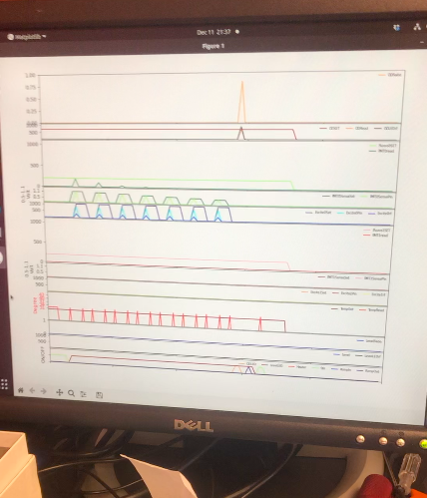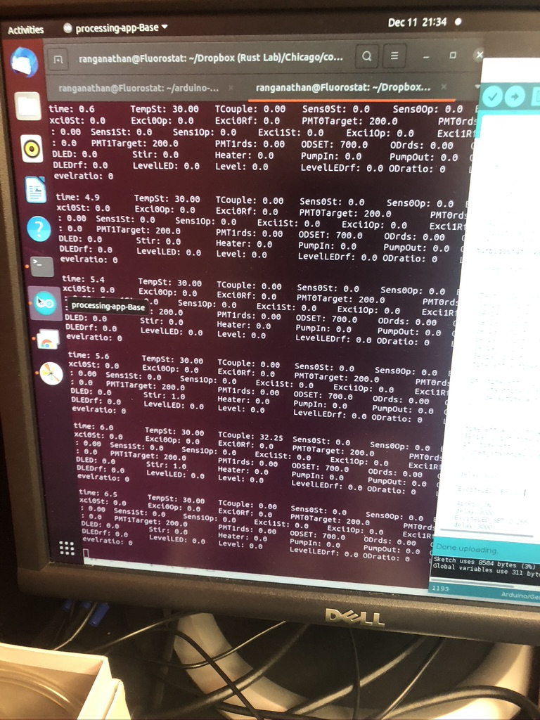

**Killing a Run**

To kill a run, close the matplotlib interactive window, kill the python script (ctrl+c in command line) and comment out all codes in the Arduino code and upload.

Now you can turn all of the components off and remove the sample

Put the probe in ethanol.

**Cleaning Up a Run**

* At the sink, remove the metal cap of the sample holder and spray it with ethanol.
* Add diluted bleach to the waste bottle, media bottle, and sample vial. Let sit until culture turns clear/white.
* Unscrew the tubing from the metal sample holder, and using a syringe flush diluted bleach through the tubing.
* Rinse all glasses, tubing and metal cap with hot tap water.
* Rinse all glasses, tubing and metal cap with 70% ethanol
* Finally, Rinse all glasses, tubing and metal cap with the research grade water.
* Autoclave before next run

**Accessing Data**

Any time you run the two colors python script, a folder will be created in “Dropbox (Rust Lab)/Chicago/Experiments” with the date it was run, and a csv of all the sample data is stored there.

**Analyzing the Data**

Find the jupyter notebook template in “Dropbox (Rust Lab)/Chicago/Code”. Copy and paste the most current template (right now FluorostatAnalysis_template_v1.4.ipynb) into the directory with the date of the experiment. This can calculate the growth rate, fluorescent reads and other basic functions.

In the same code folder the script “plot_multipleODs.py” allows you to compare runs of different dates.